**Engraved bird application fo** **rm**

**Name:** Mr/Mrs/Miss ………………………………………………………………………………………………………………………..…

**Address:**………………………………………………………………………………………………………………………………………………

…………………………………………………………………………………………………………. **Post code:** ………………………………

**Email address:** …………………………………………………………………………………………………………………………………….

**Telephone number:** …………………………………………………………………………………………………………..……………….

Please tick which bird plaque you would like to purchase:

* Small bird, £100 – 147 characters (including spaces) over six lines
* Large parrot, £250 – 177 characters (including spaces) over six lines

Please use the character count as a maximum guide, the actual count can vary depending on the characters used and any use of upper-case letters. We will consult you if any amendments need to be made.

Please write clearly in block capitals. We are unable to accept responsibility for an incorrect inscription due to illegible writing. Wording is subject to approval.

|  |  |  |  |  |  |  |  |  |  |  |  |  |  |  |  |  |  |  |  |
| --- | --- | --- | --- | --- | --- | --- | --- | --- | --- | --- | --- | --- | --- | --- | --- | --- | --- | --- | --- |
|  |  |  |  |  |  |  |  |  |  |  |  |  |  |  |  |  |  |  |  |
|  |  |  |  |  |  |  |  |  |  |  |  |  |  |  |  |  |  |  |  |
|  |  |  |  |  |  |  |  |  |  |  |  |  |  |  |  |  |  |  |  |
|  |  |  |  |  |  |  |  |  |  |  |  |  |  |  |  |  |  |  |  |
|  |  |  |  |  |  |  |  |  |  |  |  |  |  |  |  |  |  |  |  |
|  |  |  |  |  |  |  |  |  |  |  |  |  |  |  |  |  |  |  |  |
|  |  |  |  |  |  |  |  |  |  |  |  |  |  |  |  |  |  |  |  |
|  |  |  |  |  |  |  |  |  |  |  |  |  |  |  |  |  |  |  |  |
|  |  |  |  |  |  |  |  |  |  |  |  |  |  |  |  |  |  |  |  |

Please return a signed and dated copy of this form with a cheque made payable to ‘The Parks Foundation’ to The Cricket Pavilion, Winton Recreation Ground, Bournemouth, BH9 1BX or purchase online at parksfoundation.org.uk/aviary. Please use the same name and email address when you donate online to this form so we can match the transaction.

I have read the instructions and conditions set out on this form, subject to which The Parks Foundation will provide an engraved bird with an inscription and agree to be bound by them.

Signed: ……………………………………………………………… Date: …………………………………………….

*A typed version of your name can be accepted as an electronic signature*

**Conditions**

1. Throughout its existence the bird will remain in the ownership of The Parks Foundation.
2. Reasonable effort will be taken by The Parks Foundation to maintain the bird in a good condition. Although not liable for replacement, a bird which is damaged or stolen or becomes unfit to fulfil its purposes, by whatever reason or means, The Parks Foundation reserves the right to replace or refit the same entirely at its discretion and at its own expense.
3. The Parks Foundation reserves the right to move to a new location or remove completely any bird if it is deemed to be in their best interest. Notification of such action will be made to the applicant at their last known address.
4. A contribution towards maintenance costs for a period of 10 years is included. At the end of the period an attempt will be made to contact the applicant at his or her last known address to confirm if he or she is willing to make a further contribution for the next 10 years. If the applicant decides not to take up this option, the bird location will be considered available.
5. Please ensure that any changes of address are notified to The Parks Foundation.
6. We are sorry for any inconvenience or upset but are only able to put the engraved birds up on the aviary a maximum of twice a year due to how they are affixed. If you’d like a plaque displayed by a certain date, please purchase your engraved bird well in advance. Should you like further information regarding this, please contact us on 01202 123540 or [info@parksfoundation.org.uk](mailto:info@parksfoundation.org.uk).

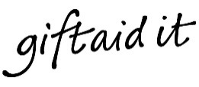

If you are a UK tax payer, you can boost your donation to The Parks Foundation by 25p for every £1 you donate. Please tick the box below.

I am a UK taxpayer and understand that if I pay less Income Tax and/or Capital Gains tax   
than the amount of Gift Aid claimed on all my donations in that tax year, it is my responsibility to pay any difference.

Please let us know if you want to cancel this declaration, change your home address or no longer pay sufficient tax.

If you are purchasing your engraved bird online you can Gift Aid your donation automatically.

**Protection Legislation**

Information that you provide will be held and used in compliance with the General Data Protection Regulation (GDPR). For further information about how we take care of and use your information please visit [parksfoundation.org.uk/privacy-policy](http://www.bournemouthparksfoundation.org.uk/privacy-policy/)

**Our bird plaques**

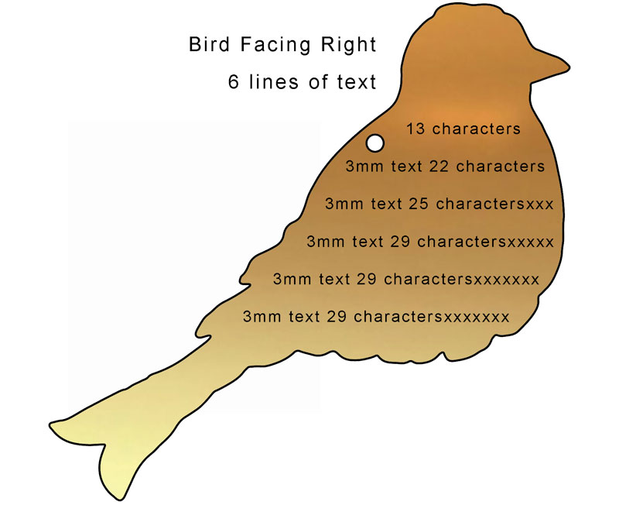Finch – 15cm

£100

147 characters

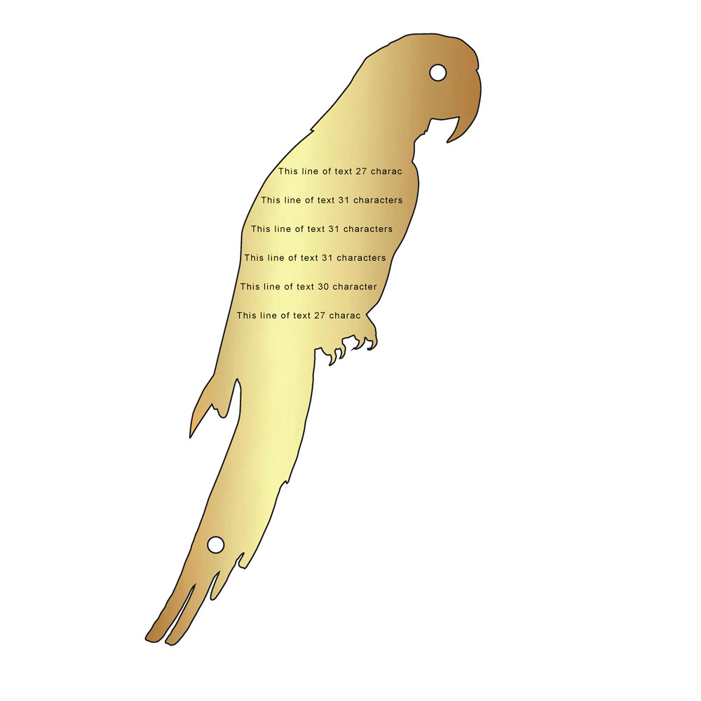

Parrot – 30cm

£250

177 characters